Software Engineering Department  
ORT Braude College

Capstone Project Phase A

**GaitStab- Gait stability Assessment**

**25-1-R-7**

Supervisor: Dr. Julia Sheidin and Dr. Avital Shulner Tal

Student: Lital Leschinsky

<https://github.com/litalleschinsky/Gait_Detection.git>

**Table of content**

1. Abstract ...............................................................................................................3   
2. Background………………………………………………………………………………………………….….4  
2.1 Introduction to Gait and Stability……………………………………………………………….….4  
2.2.1 The Impact of Physical Activity……………………………………………………………….…..4  
2.2.2 Gender Differences in Postural Control…………………………………………………….…5  
2.2.3 Aging Effects on Balance and Gait…………………………………………………………….…5  
2.2 Data Source: Experiment……………………………………………………………………………….6  
2.3. Introduction to the problem………………………………………………………………………...7  
2.4. Data Review………………………………………………………………………………………………….7  
2.4.1 Data distribution…………………………………………………………………………………………9  
2.4.2 Data Representation………………………………………………………………………………….10  
2.5 Visualization………………………………………………………………………………………………...11  
2.5.1 Visualizing Changes Over Time………………………………………………………………….11  
2.5.2 Visualization Strategy………………………………………………………………………………..11  
3. Challenges………………………………………………………………………………………………….….12  
4. Expected Achievements…………………………………………………………………………………12  
5. Process Overview…………………………………………………………………………………………..13  
5.1 Graph Creation in Colab……………………………………………………………………………….13  
5.2 Comparison of Visualization Tools………………………………………………………………..13  
5.3 Choosing Tableau for Visualization……………………………………………………………….14  
6.Research process…………………………………………………………………………………………….14  
6.1 Architecture and tools …………………………………………………………………………………15  
6.1.1backend……………………………………………………………………………………………………..15  
6.1.2 frontend……………………………………………………………………………..…………………....15  
6.2 proposed solution………………………………………………………………………………………..17  
7. Verification Plan…………………………………………………………………………………………….20  
7.1 System testing……………………………………………………………………………………………..20  
7.2 User evaluation…………………………………………………………………………………………….21  
8. References……………………………………………………………………………………………………..22

**1 Abstract**

Gait reflects a person's stability, balance, and movement patterns, and its analysis provides critical insights into mobility and the identification of potential problems with balance or gait patterns. In this project, I will analyze gait data of 27 participants from an experiment conducted at Ariel University. The data is organized in an Excel file, it contains gait data and additional characteristics such as age, gender, BMI, etc.  
The goal is to select visualizations that will present the data and changes in gait in the most clear and interactive way. To this end, I will examine advanced visualization tools and techniques, such as Tableau and D3.js, which allow for in-depth analysis of gait data over time, identifying anomalies, and tracking changes. Tableau excels in creating interactive and user-friendly dashboards, while D3.js allows for high customization and flexibility in creating web-based visualizations. Ultimately, I will select the most appropriate tools and graphs and build a dashboard that will include detailed information about the participants and their walking data over time. Special emphasis will be given to displaying changes for each person individually and for the groups to which they belong, such as age and gender.

**2 Background**

2.1 Introduction to Gait and Stability

Gait is a fundamental aspect of human movement that allows individuals to maintain mobility and perform daily activities. It requires coordinated neuromuscular control to ensure stability and balance during walking. Upright gait stability, which refers to the ability to control and minimize oscillations of the upper body while walking, is crucial for safe and efficient locomotion [1](Iosa et al., 2014). Gait stability develops over time, from early childhood through adulthood, and gradually declines due to aging-related changes in muscle strength, sensory feedback, and cognitive processing.

2.2.1 The Impact of Physical Activity

The benefits of physical activity on gait stability and overall physical performance are well-documented in a study published in the British Journal of Sports Medicine (1994). The research emphasizes that regular physical exercise, including strength training and balance exercises, plays a significant role in enhancing postural control, neuromuscular coordination, and gait stability across all age groups. By improving muscle strength and coordination, physical activity helps reduce gait variability, which is crucial for maintaining stability during movement. The study also highlights that consistent physical activity contributes to better overall mobility and a reduced risk of injury, as it enhances the body's ability to respond to external perturbations. Furthermore, it points out that even moderate exercise can have a substantial impact on stabilizing gait, leading to improved functional performance and quality of life. These findings underline the importance of incorporating regular physical activity into daily routines for individuals of all ages to improve their physical health, stability, and overall well-being [2](British Journal of Sports Medicine, 1994).

2.2.2 Gender Differences in Postural Control

Gender differences in postural control have been extensively studied, with significant variations in balance and stability between men and women. A study published in (Gait & Posture,2019) suggests that women generally experience greater postural sway and increased gait variability compared to men. These differences are primarily attributed to variations in muscle mass distribution, hormonal influences, and anatomical characteristics. Women tend to have a wider pelvis and higher center of mass, which can influence their balance and stability during walking. Hormonal fluctuations, particularly those related to the menstrual cycle, pregnancy, and menopause, can also affect muscle strength and ligamentous flexibility, which may impact postural control. On the other hand, men typically possess greater muscle mass and strength, particularly in the lower body, which contributes to better postural control and less sway. These findings emphasize the importance of considering gender-specific factors when assessing postural control and designing interventions to enhance balance and prevent falls. Personalized approaches that account for these differences are essential for improving stability and functional mobility in both men and women. [3](Gait & Posture,2019)

2.2.3 Aging Effects on Balance and Gait

Aging is associated with significant changes in balance and gait, which can lead to increased risk of falls and mobility impairment. According to a study published in Liver International (2019), age-related changes in neuromuscular function, including reduced muscle mass, strength, and flexibility, play a critical role in declining balance and gait stability. The research highlights that older adults often experience slower reaction times, decreased proprioception, and diminished postural control, which contribute to increased gait variability and difficulty maintaining balance during movement. Additionally, cognitive decline and the degradation of sensory systems, such as vision and vestibular function, can further impair the ability to stabilize gait. These age-related factors significantly elevate the risk of falls and injuries. The study suggests that interventions, such as strength training, balance exercises, and cognitive training, can mitigate some of the adverse effects of aging on balance and gait. By improving muscle strength, flexibility, and coordination, older adults can maintain better mobility and stability, which are essential for preventing falls and   
promoting independence in later years [4] (Liver International, 2019).

2.2 Data Source: Experiment

The data for this research was obtained from an experiment conducted at Ariel University under the guidance of Lihi Deri. The experiment aimed to assess human gait stability using a smartphone that participants held during their walking sessions. This approach allowed to gather real-time gait parameters and demographic details (age, gender, BMI, etc.) from 27 participants, creating a diverse dataset to support the study’s objectives.

The primary objective of the experiment was to explore the potential for using smartphone-based gait analysis to predict age group classification based on walking patterns. Given the increasing accessibility of smartphones, this approach may be beneficial in various real-world scenarios, particularly in identifying gait-related risk factors for falls and balance issues in middle-aged and older adults.

This study served as a pilot for developing a deeper model capable of identifying significant age-related patterns in human gait. The findings from this experiment provide valuable input for further research on the relationship between gait, stability, and aging, with the potential to support early detection of movement abnormalities and help guide personalized interventions for fall prevention.

figure 1: An illustrative depiction captured from the Physics Toolbox Accelerometer depicting how the subject should hold his smartphone during the session.

2.3 Introduction to the problem

The gait detection data has been collected and is currently stored in a large Excel table. This dataset includes numerous parameters related to the walking patterns of participants. However, the current format of the data makes it difficult to process, understand, and analyze effectively. Since the goal of this data is to assess balance and stability during walking, it is crucial to present the information in a way that highlights meaningful patterns, making it easier to interpret and evaluate.The main issue is the lack of clarity in the data format, which complicates the identification of relationships between different variables and makes it challenging to understand the information in various contexts. For example, it becomes hard to track changes in walking stability according to different demographic factors or physical attributes of participants.

To improve the ability to understand and process this information in a way that allows for effective tracking of balance and stability, there is a need to present the data in a clearer, more intuitive, and accessible manner. One of the main challenges in this project is selecting the most appropriate types of graphs and visualizations that best display each aspect of the data. Each visualization should not only present the information in an aesthetically pleasing way but also facilitate the identification of patterns and trends, helping users understand the impact of various variables.

2.4 Data Review  
figure 2: present part of the data for the first person.

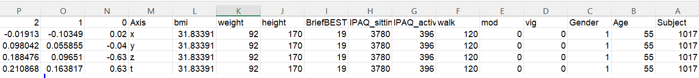

The dataset contains detailed gait detection data collected. Each participant’s data consists of four rows representing measurements along four axes (X, Y, Z) and an additional axis (T) representing the combined total acceleration from all axes. These values, recorded in meters per second squared, represent the acceleration on each axis at a given moment during the measurement. The dataset is structured as follows:  
There are 108 rows in total, representing data for 27 individuals (14 males and 13 females), each individual contributing 4 rows.

The dataset contains 2,033 columns, with the first 2,000 columns representing accelerometer readings recorded every 1/100th of a second over a 20-second interval. These measurements reflect the accelerations in all three axes of motion. In addition to the accelerometer data, the dataset includes several features that describe the individual participants, such as their age, gender, height, weight, and Body Mass Index (BMI).

Furthermore, participants filled out an IPAQ (International Physical Activity Questionnaire) to provide information about their physical activity levels.   
The dataset includes columns for three types of activity intensity: Vigorous (VIG), Moderate (MOD), and Walking (WALK), along with the total physical activity score calculated from these responses. The IPAQ score is computed by multiplying the weekly minutes of each activity by specific coefficients: 8 for vigorous activity, 4 for moderate activity, and 3.3 for walking. This results in the IPAQ_activity column, which gives the total activity score. The dataset also includes the IPAQ_sitting column, representing the number of minutes per week that the participant spends sitting, which does not contribute to the activity score but is an additional characteristic. A crucial column, briefBESTest, evaluates the stability of each participant. A score between 22 and 24 indicates high stability, like a young adult, while scores below this range indicate lower stability, resembling that of an older individual (over the age of 45). Scores as low as 0 indicate complete instability, meaning the person could be bedridden. The briefBESTest column provides insights into the balance and stability of the participants.

Finally, the dataset includes summary statistics for the accelerometer data, such as minimum, maximum, and standard deviation for each of the axes. These features, based on prior literature, have been found to contribute to the prediction of stability and balance.

2.4.1 Data distribution

figure 3: Gender

The chart illustrates the distribution of participants according to gender,   
with a total of 14 males and 13 females. This visualization offers a clear representation of the gender composition within the dataset, allowing for a quick understanding of the participant demographic. It helps highlight the balance or any potential skew in gender representation, which could be relevant for further analysis or interpretation of the data.

figure 4: Age range

The chart illustrates the distribution of participants across three age groups: 20-40, 40-60, and 60-80. It offers a clear visual representation of how participants are spread across each age group, providing insight into the data's composition. This segmentation can be useful for identifying trends or differences in results, such as variations in gait or stability performance, depending on age.

Figure 5: Correlation

This graph visualizes the correlations between numerical variables such as Age, BMI, and BriefBESTest scores. A higher positive correlation (closer to 1) suggests that as one variable increases, the other does as well. Conversely, a strong negative correlation (closer to -1) indicates that as one variable increases, the other decreases. This type of visualization helps identify potential relationships between variables, allowing for deeper insights into how factors like age and BMI may influence stability, as reflected by the BriefBESTest scores.

2.4.2 Data Representation

figure 6: Gait detection of 27 participants

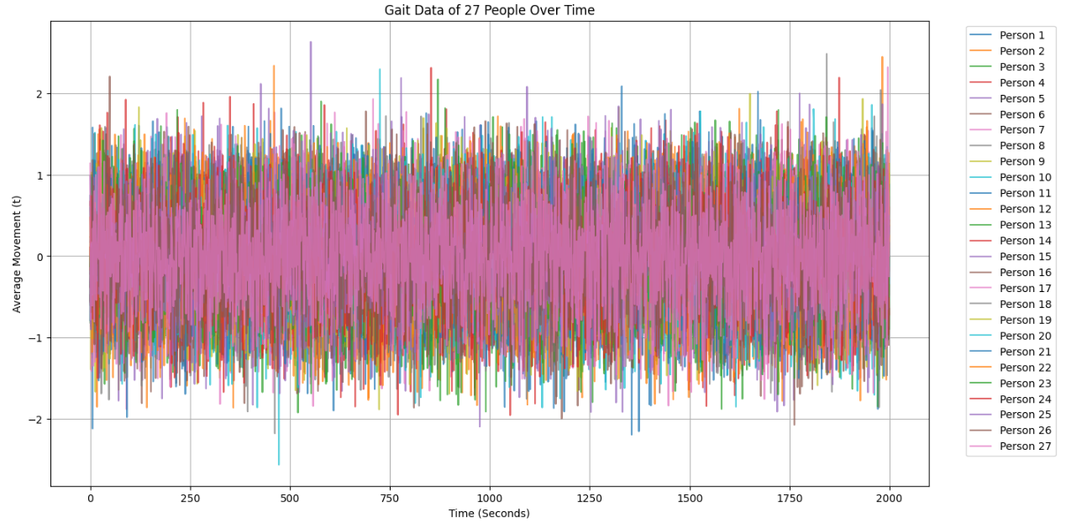

This graph illustrates the gait detection data collected from 27 participants over time, but its complexity makes it challenging to draw meaningful conclusions. The vast amount of data points and the lack of clear separation between individual measurements make it difficult to identify patterns or trends. The graph's cluttered presentation prevents an intuitive understanding of how factors like age, gender, or stability scores may affect the gait patterns of each participant, highlighting the need for a more effective way of visualizing the data.

2.5 Visualization

It is a method of presenting data and information in a graphical format, aimed at making the information easier to understand and more accessible. Through graphs, charts, maps, and other graphical elements, it is possible to illustrate processes, trends, and structures in a way that is often easier to process and comprehend than through text or tables. Visualization enables the identification of patterns, correlations, and differences in the data in an intuitive way, understanding the information and drawing conclusions more quickly and effectively.

2.5.1 Visualizing Changes Over Time

Time-evolving visualizations are essential for analyzing how walking patterns change over time. By tracking gait over extended periods, these visualizations allow us to identify important trends, variations, and anomalies in movement. This approach provides a clearer representation of a person’s walking behavior, making it easier to detect subtle changes in stability and balance. As I observe the progression of gait, we can better assess the individual’s mobility and spot any signs of deterioration or improvement. Ultimately, time-evolving visualizations offer valuable insights into gait behavior, helping us understand the long-term shifts in walking patterns and their potential underlying causes. By using this method, we can draw more accurate conclusions regarding a person’s walking abilities and track their progress over time.

2.5.2 Visualization Strategy

During the analysis of gait detection data, it became evident that no single visualization could fully represent the dataset. Given the complexity of the data, which includes demographic information, physical parameters, movement metrics, and behavioral aspects over time, a comprehensive understanding requires a combination of multiple visualizations.

To effectively present the data, a dashboard integrating various graphs is necessary, with each visualization emphasizing different aspects of the dataset. As of now, no final decision has been made regarding the exact visualizations to be used in the final stage. The next phase will focus on selecting the most appropriate visualizations based on statistical analysis, clarity, and their ability to highlight meaningful patterns. The selection process will ensure that the data is presented in a way that facilitates pattern recognition and insight extraction.

**3 Challenges**

One of the main challenges in visualizing gait detection data is representing changes over time. The data tracks movement patterns for each participant over an extended period, and it's crucial to display these changes clearly and meaningful. Another challenge arises from the need to present the data for 27 participants simultaneously. Finding a visualization that effectively compares all participants while also emphasizing individual differences is not straightforward. Additionally, the dataset contains a variety of variables, including accelerometer data, physical attributes, and activity levels, which adds complexity to the task of presenting the data in a way that highlights the most important insights.

**4 Expected Achievements**

The goal is to present the data through visualizations that highlight changes over time, enabling a clearer understanding of how individual walking patterns evolve. Additionally, the visualizations will allow for easy comparisons between individuals, providing insights into how each participant's data contrasts with others. By grouping individuals into relevant categories, such as age and gender, the data will be presented in a more organized manner, making it easier to identify trends and patterns. Ultimately, the aim is to present the information in a clear and understandable way, ensuring that the visualizations convey meaningful insights effectively.

**5 Process overview**

Initially, data visualization was performed using Google Colab, a cloud-based platform that allows for easy execution of Python scripts and the utilization of advanced data processing libraries. However, as the project progressed, it became necessary to explore additional tools to enhance visualization quality and interactivity. Two primary tools, Tableau and D3.js, were evaluated for their suitability in presenting gait detection data.

5.1 Graph Creation in Colab

For the preliminary visualization stage, Google Colab was used with the following key libraries:

Pandas –For data manipulation and preprocessing.   
Matplotlib – To generate basic graphical representations.   
Seaborn – To visualize statistical relationships between variables.   
Plotly – To create interactive graphs for data exploration.

Colab provided an initial understanding of data trends, helping to identify the most relevant visualization types for further analysis.

5.2 Comparison of Tableau and D3.js for Data Visualization

Given the limitations of static graphs in Colab, the next step was to evaluate two advanced visualization tools: Tableau and D3.js.

Tableau is a no-code platform that allows users to create interactive visualizations. It offers a user-friendly interface and integrates seamlessly with data sources such as Excel. Tableau supports the creation of dashboards with various filters, providing easy access to different insights from the data. However, its customization options are limited when compared to code-based solutions. Additionally, while Tableau performs well with moderate-sized datasets, it may face performance issues when handling very large datasets, which can result in slower processing times [5](Mehmood & Javed, 2021).  
D3.js is a JavaScript library that provides full control over custom visualizations. It allows for the creation of highly tailored visualizations, with extensive interactivity features, such as tooltips, zooming, and updates. D3.js is highly flexible, enabling the design of complex visualizations that meet specific requirements. However, it requires advanced coding skills and substantial development time, which can make it less accessible for those without a background in programming or for users seeking quicker solutions [6](Gehlenborg et al., 2021).

5.3 Choosing Tableau for Visualization

Tableau was chosen for the next phase of visualization due to its ease of use, interactivity, and seamless integration with the existing dataset. The decision was driven by the need for:

A user-friendly interface that does not require extensive coding. The ability to interactively explore and filter data. A dashboard environment that can effectively present trends and comparisons. Another critical factor in the decision was Tableau's ability to clearly present data that changes over time. Since the dataset captures participants' walking patterns across multiple time intervals, it is essential to visualize these changes effectively. Displaying these variations helps identify trends and fluctuations in gait stability, enabling the extraction of meaningful insights about how walking patterns evolve or differ across time.

**6 Research process**

At the beginning of the research, I analyzed the Excel dataset containing gait detection data, examining its structure, content, and key variables. I then investigated the relationships between these variables, content, and the factors influencing stability and balance. This initial phase allowed me to understand the key variables and how they relate to gait patterns.

Following this, I explored various visualization techniques and studied different types of graphs that represent data over time, focusing on how gait stability trends can be effectively communicated. Through this investigation, I concluded that visualization plays a crucial role in making data more accessible, clear, and easy to interpret, especially for identifying movement abnormalities and tracking balance variations.

Despite these findings, the optimal visualization method has not yet been determined. The next phase of the research will focus on identifying the most effective visualization approach to ensure that the insights derived from the data are both meaningful and comprehensible.

6.1 Architecture and tools

The system architecture for this project consists of a **backend** and **frontend**, each playing a distinct role in handling user interactions, data processing, and visualization

6.1.1 Backend

The backend is responsible for handling data processing, ensuring smooth communication between the frontend and Tableau, and managing user data.

Technologies Used:  
Programming Language: Python  
Framework: Flask / Fast API (for handling API requests)  
Data Processing: Pandas, NumPy (for pre-processing the uploaded file)  
Tableau API: To send processed data to Tableau and retrieve visualization results.  
  
6.1.2 Frontend

The frontend is responsible for the user interface, file uploads, and displaying visualized data.

Technologies Used:  
Programming Language: HTML, CSS, JavaScript (React.js / Vue.js)  
Visualization Libraries: D3.js, Chart.js (for additional local visualization if needed)  
UI Frameworks: Material-UI / Bootstrap (for styling and responsiveness)  
HTTP Client: Axios / Fetch API (for communicating with the backend)  
File Upload Handling: React Dropzone / Multer (for managing file uploads)

Website Structure:  
HTML: For structuring the user interface elements.  
CSS: Provides styling for better user experience.  
JavaScript (React/Vue): Handles dynamic content updates and user interactions.  
API Requests: The frontend interacts with the backend through RESTful APIs.

Frontend

Backend

User

Display graphs

Creating graphs

6.2 proposed solution

The system comprises a collection of graphs that together provide a structured representation of the data. Each visualization is strategically arranged to highlight key trends and comparisons, offering a comprehensive view of the dataset. This organized layout enables to quickly grasp the main insights. First, we upload the file:

figure 7

figure 8

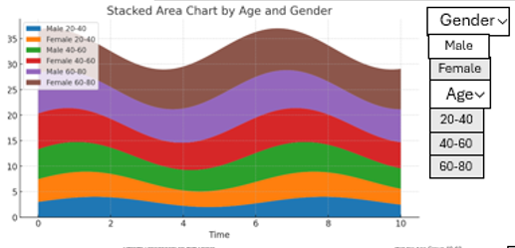

figure 8 represents walking progression over time, with the y-axis depicting the advancement of walking and the x-axis representing time. It features six distinct colors, each corresponding to a different age group. Within each age group, the data is further divided by gender, providing a clear visualization of how walking patterns change over time across different demographics. Additionally, the graph includes filtering options, allowing users to view specific age groups and genders for a more focused analysis.

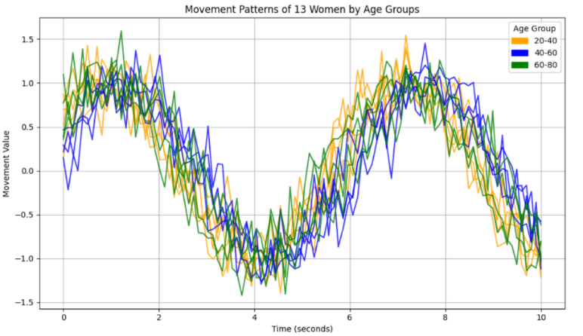  
 Figure 9 displays the walking distribution of women across all age groups.

figure 9

figure 10

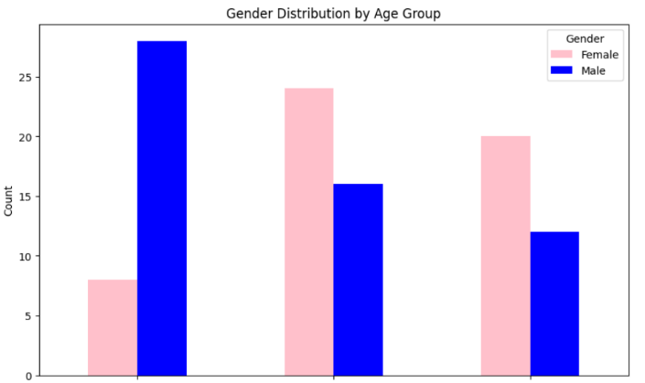

40-60

20-40

60-80

Figure 10 illustrates the age distribution across different age groups. A pink bar represents the number of women, while a blue bar represents the number of men. Users can select a specific age group to display additional data.

figure 11

Figure 11 presents additional data such as age, BMI, and BriefBESTest scores based on the age group selected in the figure 10. It also allows filtering by gender. Clicking on one of the lines displays Figure 12.

figure 12

Figure 12 illustrates the walking progression of an individual over time, showing how their gait changes throughout the observed period.

**7 Verification Plan**

In developing the project, it's essential to ensure that the system functions correctly and provides a positive user experience. A comprehensive evaluation plan is crucial for assessing both the technical performance and the usability of the system. The following evaluation plan is divided into two main sections: System Testing and User Evaluation.

7.1 System testing

|  |  |  |  |  |  |
| --- | --- | --- | --- | --- | --- |
| Test  number | Test type | Description | Expected  result | Testing method | Notes |
| 1 | Data upload | Verify the ability to upload data to the website. | Data uploads successfully without errors. | Upload a data file to the website and confirm successful upload. | Ensure the file is in a supported format. |
| 2 | Tableau integration | Confirm connection between the website and Tableau with the uploaded data. | Successful connection with data accessible in Tableau. | Connect Tableau to the website and check data availability. | Verify that data is correctly imported into Tableau. |
| 3 | Data visualization | Ensure Tableau displays data correctly. | Data is presented clearly and accurately. | Review Tableau dashboards to assess data presentation. | Confirm that graphs and tables are displayed correctly. |
| 4 | Data update | Test if the file loads completely and updates with new data entries. | Data updates as new entries are added. | Add new data to the file and check for updates in Tableau. | Ensure the system supports data updates. |
| 5 | Filter functionality | Test the functionality of applied filters. | Filters operate as intended, refining data accordingly. | Apply various filters and verify the results. | Confirm that filters are correctly configured. |
| 6 | Graph display on website | Verify that users can view graphs on the website. | Graphs are displayed clearly and are accessible to users. | Access the website and check for graph visibility. | Ensure graphs are responsive across different devices. |

7.2 User evaluation

In developing the project, I aim to ensure that the system is intuitive, easy to use, and that the visualizations presented in it are clear and understandable, allowing for relevant conclusions to be drawn. To this end, I plan to collect feedback from users through surveys, to understand their preferences, expectations, and overall satisfaction levels, thus identifying areas for improvement.

8. References

1. Iosa, M., Fusco, A., Morone, G., & Paolucci, S. (2014). Development and decline of upright gait stability. Frontiers in Aging Neuroscience. <https://doi.org/10.3389/fnagi.2014.00014>

2.British Journal of Sports Medicine. (1994). The effects of physical activity on human gait stability: A review. *British Journal of Sports Medicine, 28*(4), 247-251  
<https://bjsm.bmj.com/content/28/4/247>

3. Gait & Posture. (2019). Gender differences in postural control: A review of the biomechanics of balance. *Gait & Posture, 71*, 60-67. <https://doi.org/10.1016/j.gaitpost.2019.04.005>

4. Liver International. (2019). Aging effects on balance and gait: Mechanisms, interventions, and impact on mobility. *Liver International, 39*(6), 1132-1141  
<https://onlinelibrary.wiley.com/doi/full/10.1002/lio2.252>

5. Mehmood, Z., & Javed, M. (2021). *Tableau for Data Visualization: A Comparative Analysis*. International Journal of Information Engineering and Electronic Business, 11(1), 30-40. Retrieved from <https://www.mecs-press.org/ijieeb/ijieeb-v11-n1/IJIEEB-V11-N1-3.pdf>

6. Gehlenborg, N., O’Donoghue, S. I., & Pfister, H. (2021). *A Survey of Visualization Tools for Data Science and Machine Learning*. arXiv:2108.02299. Retrieved from <https://arxiv.org/pdf/2108.02299>

1. . Iosa, M., Fusco, A., Morone, G., & Paolucci, S. (2014). Development and decline of upright gait stability. Frontiers in Aging Neuroscience. <https://doi.org/10.3389/fnagi.2014.00014>
2. British Journal of Sports Medicine. (1994). The effects of physical activity on human gait stability: A review. *British Journal of Sports Medicine, 28*(4), 247-251  
   <https://bjsm.bmj.com/content/28/4/247>
3. . Gait & Posture. (2019). Gender differences in postural control: A review of the biomechanics of balance. *Gait & Posture, 71*, 60-67. <https://doi.org/10.1016/j.gaitpost.2019.04.005>
4. Liver International. (2019). Aging effects on balance and gait: Mechanisms, interventions, and impact on mobility. *Liver International, 39*(6), 1132-1141  
   <https://onlinelibrary.wiley.com/doi/full/10.1002/lio2.252>
5. . Mehmood, Z., & Javed, M. (2021). *Tableau for Data Visualization: A Comparative Analysis*. International Journal of Information Engineering and Electronic Business, 11(1), 30-40. Retrieved from <https://www.mecs-press.org/ijieeb/ijieeb-v11-n1/IJIEEB-V11-N1-3.pdf>
6. . Gehlenborg, N., O’Donoghue, S. I., & Pfister, H. (2021). *A Survey of Visualization Tools for Data Science and Machine Learning*. arXiv:2108.02299. Retrieved from <https://arxiv.org/pdf/2108.02299>